

NAME: BISMA FATIMA
CLASS: CS A
ROLL NO: F24605036
COURSE: DATA STRUCTURE
COURSE CODE: CS-211
LECTURER: SIR MEHRAN YOUSAF

LAB 08

Practice Tasks
Task 1: The Circular Printer Spooler (Circular Queue using SLL)
Implement a class CircularQueue using a Singly Linked List.
- Structure: Maintain pointers front and rear.
- Constraint: rear->next must always point to front.
- Operations: enqueue(string document), dequeue(), display().
- Logic Check: When displaying, ensure your loop doesn't run infinitely. Use a do-while loop checking current != front.

PROGRAM
#include <iostream>
using namespace std;
struct Node {
string data;
Node* next;
Node(string val) {
data = val;
next = NULL;
}
};
class CircularQueue {
private:
Node* front;
Node* rear;
public:
CircularQueue() {
front = rear = NULL;
}
void enqueue(string document) {
Node* newNode = new Node(document);
if (front == NULL) {
front = rear = newNode;
rear->next = front;
} else {
rear->next = newNode;
rear = newNode;
rear->next = front;
}
cout << "Enqueued: " << document << endl;
}
void dequeue() {
if (front == NULL) {
cout << "Error: Queue is empty." << endl;
return;
}
if (front == rear) {
cout << "Dequeued: " << front->data << endl;
delete front;
front = rear = NULL;
} else {
Node* temp = front;
cout << "Dequeued: " << temp->data << endl;
front = front->next;
rear->next = front;
delete temp;
}
}
void display() {
if (front == NULL) {
cout << "Queue is empty." << endl;
return;
}
Node* current = front;
cout << "Circular Queue: ";
do {
cout << current->data << " -> ";
current = current->next;
} while (current != front);
cout << "(back to front)" << endl;
}
};
int main() {
CircularQueue spooler;
spooler.enqueue("Doc1.pdf");
spooler.enqueue("Doc2.docx");
spooler.enqueue("Doc3.pptx");
spooler.display();
spooler.dequeue();
spooler.display();
spooler.dequeue();
spooler.dequeue();
spooler.dequeue();
return 0;
}

OUTPUT
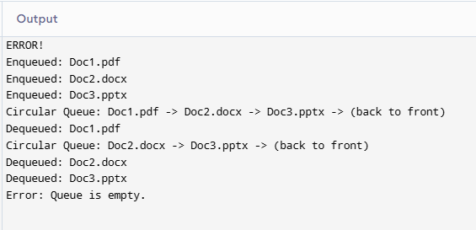

Task 2: The Two-Way Priority Line (Priority Queue using DLL)
Re-implement the Priority Queue using a Doubly Linked List.
- Node: int data, int priority, Node* next, Node* prev.
- Requirement: The enqueue function must correctly link both next and prev pointers when inserting a node in the middle of the list.
- Feature: Add a function displayReverse() that prints the queue from lowest priority (tail) to highest priority (head).

PROGRAM
#include <iostream>
using namespace std;
struct Node {
int data;
int priority;
Node* next;
Node* prev;
Node(int val, int prio) {
data = val;
priority = prio;
next = prev = NULL;
}
};
class PriorityQueueDLL {
private:
Node* head;
Node* tail;
public:
PriorityQueueDLL() {
head = tail = NULL;
}
void enqueue(int data, int priority) {
Node* newNode = new Node(data, priority);
if (head == NULL) {
head = tail = newNode;
return;
}
if (priority < head->priority) {
newNode->next = head;
head->prev = newNode;
head = newNode;
return;
}
Node* temp = head;
while (temp->next != NULL && temp->next->priority <= priority) {
temp = temp->next;
}
if (temp->next == NULL) {
temp->next = newNode;
newNode->prev = temp;
tail = newNode;
} else {
newNode->next = temp->next;
newNode->prev = temp;
temp->next->prev = newNode;
temp->next = newNode;
}
}
void dequeue() {
if (head == NULL) {
cout << "Error: Queue is empty." << endl;
return;
}
Node* temp = head;
cout << "Dequeued: " << temp->data << " (priority " << temp->priority << ")" << endl;
head = head->next;
if (head != NULL) {
head->prev = NULL;
} else {
tail = NULL;
}
delete temp;
}
void display() {
if (head == NULL) {
cout << "Queue is empty." << endl;
return;
}
Node* temp = head;
while (temp != NULL) {
cout << "[" << temp->data << ", p=" << temp->priority << "] -> ";
temp = temp->next;
}
cout << "NULL" << endl;
}
void displayReverse() {
if (tail == NULL) {
cout << "Queue is empty." << endl;
return;
}
Node* temp = tail;
while (temp != NULL) {
cout << "[" << temp->data << ", p=" << temp->priority << "] -> ";
temp = temp->prev;
}
cout << "NULL" << endl;
}
};
int main() {
PriorityQueueDLL pq;
pq.enqueue(10, 2);
pq.enqueue(20, 1);
pq.enqueue(30, 3);
pq.enqueue(40, 2);
pq.display();
pq.displayReverse();
pq.dequeue();
pq.display();
return 0;
}

OUTPUT
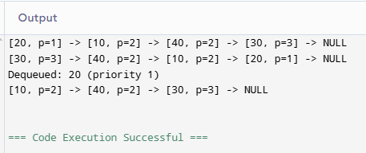
Task 3: VIP vs. Regular Customers
Create a system with two separate queues inside a ClubEntry class.
- vipQueue (High Priority)
- regularQueue (Standard Priority)
- Function: enterClub(int id, bool isVIP).
- Function: processEntry(). This function should always check if vipQueue has people. If yes, dequeue from VIP. Only if VIP is empty, dequeue from regularQueue.
- Implementation: Use standard linked lists (no sorting needed within the individual queues, the priority logic is in the processEntry function).

PROGRAM
#include <iostream>
using namespace std;
struct Node {
int id;
Node* next;
Node(int val) {
id = val;
next = NULL;
}
};
class Queue {
private:
Node* front;
Node* rear;
public:
Queue() {
front = rear = NULL;
}
void enqueue(int id) {
Node* newNode = new Node(id);
if (rear == NULL) {
front = rear = newNode;
return;
}
rear->next = newNode;
rear = newNode;
}
int dequeue() {
if (front == NULL) {
return -1;
}
Node* temp = front;
int val = temp->id;
front = front->next;
if (front == NULL) {
rear = NULL;
}
delete temp;
return val;
}
bool isEmpty() {
return front == NULL;
}
void display() {
Node* temp = front;
while (temp != NULL) {
cout << temp->id << " -> ";
temp = temp->next;
}
cout << "NULL" << endl;
}
};
class ClubEntry {
private:
Queue vipQueue;
Queue regularQueue;
public:
void enterClub(int id, bool isVIP) {
if (isVIP) {
vipQueue.enqueue(id);
cout << "VIP customer " << id << " entered the queue." << endl;
} else {
regularQueue.enqueue(id);
cout << "Regular customer " << id << " entered the queue." << endl;
}
}
void processEntry() {
if (!vipQueue.isEmpty()) {
int id = vipQueue.dequeue();
cout << "VIP customer " << id << " entered the club." << endl;
} else if (!regularQueue.isEmpty()) {
int id = regularQueue.dequeue();
cout << "Regular customer " << id << " entered the club." << endl;
} else {
cout << "No customers waiting." << endl;
}
}
void displayQueues() {
cout << "VIP Queue: ";
vipQueue.display();
cout << "Regular Queue: ";
regularQueue.display();
}
};
int main() {
ClubEntry club;
club.enterClub(101, true);
club.enterClub(102, false);
club.enterClub(103, true);
club.enterClub(104, false);
club.displayQueues();
club.processEntry();
club.processEntry();
club.processEntry();
club.processEntry();
club.processEntry();

return 0;
}

OUTPUT
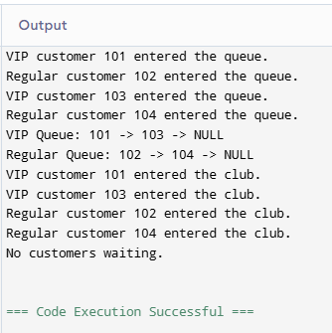

Unseen Tasks
Objective: Assess logical application of queues in complex scenarios.
Task 1: OS Process Scheduler (The "Aging" Technique)
In operating systems, low-priority processes might starve (never get CPU time) if high-priority processes keep arriving.
- Goal: Modify your Singly Linked List Priority Queue.
- Function: updatePriorities().
- Logic: Every time a dequeue() operation happens, iterate through the remaining nodes in the queue. If a node has priority > 1 (remember, 1 is highest), decrement its priority value by 1 (making it more important).
- Example: A process with priority 5 waits. After 3 dequeues of other processes, its priority becomes 2.
- Note: This technically breaks the sorted order of the list. You must decide: do you re-sort the list after updating, or do you search for the highest priority during dequeue? (Re-sorting is preferred for this task).

PROGRAM
#include <iostream>
using namespace std;
struct Node {
int data;
int priority;
Node* next;
Node(int val, int prio) {
data = val;
priority = prio;
next = NULL;
}
};
class PriorityQueueSLL {
private:
Node* head;
public:
PriorityQueueSLL() {
head = NULL;
}
void enqueue(int data, int priority) {
Node* newNode = new Node(data, priority);
if (head == NULL || priority < head->priority) {
newNode->next = head;
head = newNode;
return;
}
Node* temp = head;
while (temp->next != NULL && temp->next->priority <= priority) {
temp = temp->next;
}
newNode->next = temp->next;
temp->next = newNode;
}
void dequeue() {
if (head == NULL) {
cout << "Error: Queue is empty." << endl;
return;
}
Node* temp = head;
cout << "Dequeued: " << temp->data << " (priority " << temp->priority << ")" << endl;
head = head->next;
delete temp;
updatePriorities();
resort();
}
void updatePriorities() {
Node* temp = head;
while (temp != NULL) {
if (temp->priority > 1) {
temp->priority -= 1;
}
temp = temp->next;
}
}
void resort() {
if (head == NULL || head->next == NULL) return;
Node* sorted = NULL;
Node* current = head;
while (current != NULL) {
Node* nextNode = current->next;
if (sorted == NULL || current->priority < sorted->priority) {
current->next = sorted;
sorted = current;
} else {
Node* temp = sorted;
while (temp->next != NULL && temp->next->priority <= current->priority) {
temp = temp->next;
}
current->next = temp->next;
temp->next = current;
}
current = nextNode;
}
head = sorted;
}
void display() {
if (head == NULL) {
cout << "Queue is empty." << endl;
return;
}
Node* temp = head;
while (temp != NULL) {
cout << "[" << temp->data << ", p=" << temp->priority << "] -> ";
temp = temp->next;
}
cout << "NULL" << endl;
}
};
int main() {
PriorityQueueSLL pq;
pq.enqueue(101, 5);
pq.enqueue(102, 2);
pq.enqueue(103, 4);
pq.enqueue(104, 1);
pq.display();
pq.dequeue();
pq.display();
pq.dequeue();
pq.display();
pq.dequeue();
pq.display();
return 0;
}

OUTPUT
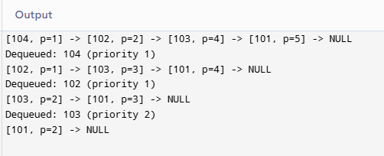
Task 2: Task Merger (Merging K-Sorted Queues)
You are given 3 separate Priority Queues (linked lists), already sorted by priority.
- Goal: Write a function PriorityQueue* mergeQueues(PriorityQueue* q1, PriorityQueue* q2, PriorityQueue* q3) that merges them into a single, valid, sorted Priority Queue.
- Constraint: You cannot create new nodes. You must re-wire the existing pointers (next) to weave the lists together efficiently.
- Hint: Compare the heads of the queues, pick the highest priority, attach it to your result, and move that queue's head forward.

PROGRAM
#include <iostream>
using namespace std;
struct Node {
int data;
int priority;
Node* next;
Node(int val, int prio) {
data = val;
priority = prio;
next = NULL;
}
};
class PriorityQueue {
public:
Node* head;
PriorityQueue() {
head = NULL;
}
void enqueue(int data, int priority) {
Node* newNode = new Node(data, priority);
if (head == NULL || priority < head->priority) {
newNode->next = head;
head = newNode;
return;
}
Node* temp = head;
while (temp->next != NULL && temp->next->priority <= priority) {
temp = temp->next;
}
newNode->next = temp->next;
temp->next = newNode;
}
void display() {
Node* temp = head;
while (temp != NULL) {
cout << "[" << temp->data << ", p=" << temp->priority << "] -> ";
temp = temp->next;
}
cout << "NULL" << endl;
}
};
PriorityQueue* mergeTwoQueues(PriorityQueue* q1, PriorityQueue* q2) {
PriorityQueue* result = new PriorityQueue();
Node* dummy = new Node(0, 0);
Node* tail = dummy;
Node* h1 = q1->head;
Node* h2 = q2->head;
while (h1 != NULL && h2 != NULL) {
if (h1->priority < h2->priority) {
tail->next = h1;
h1 = h1->next;
} else {
tail->next = h2;
h2 = h2->next;
}
tail = tail->next;
}
if (h1 != NULL) tail->next = h1;
if (h2 != NULL) tail->next = h2;
result->head = dummy->next;
delete dummy;
return result;
}
PriorityQueue* mergeQueues(PriorityQueue* q1, PriorityQueue* q2, PriorityQueue* q3) {
PriorityQueue* temp = mergeTwoQueues(q1, q2);
PriorityQueue* finalResult = mergeTwoQueues(temp, q3);
return finalResult;
}
int main() {
PriorityQueue q1, q2, q3;
q1.enqueue(101, 1);
q1.enqueue(102, 4);
q2.enqueue(201, 2);
q2.enqueue(202, 5);
q3.enqueue(301, 3);
q3.enqueue(302, 6);
cout << "Queue 1: "; q1.display();
cout << "Queue 2: "; q2.display();
cout << "Queue 3: "; q3.display();
PriorityQueue* merged = mergeQueues(&q1, &q2, &q3);
cout << "Merged Queue: ";
merged->display();

return 0;
}

OUTPUT
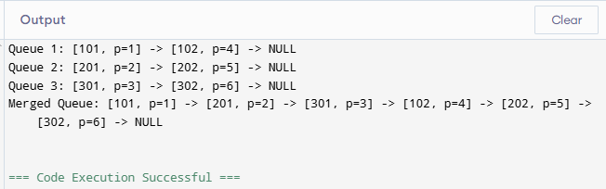
Task 3: The Circular Deque (Double-Ended Queue) using DLL
Implement a Circular Deque using a Doubly Linked List.
- Operations:
  - insertFront(val)
  - insertRear(val)
  - deleteFront()
  - deleteRear()
- Constraint: The list must be circular. rear->next = front and front->prev = rear.
- Complexity: Ensure all 4 operations run in $O(1)$ time complexity. This requires perfect management of front and rear pointers.

PROGRAM
#include <iostream>
using namespace std;
struct Node {
int data;
Node* next;
Node* prev;
Node(int val) {
data = val;
next = prev = NULL;
}
};
class CircularDeque {
private:
Node* front;
Node* rear;
public:
CircularDeque() {
front = rear = NULL;
}
void insertFront(int val) {
Node* newNode = new Node(val);
if (front == NULL) {
front = rear = newNode;
front->next = rear;
rear->prev = front;
rear->next = front;
front->prev = rear;
return;
}
newNode->next = front;
newNode->prev = rear;
front->prev = newNode;
rear->next = newNode;
front = newNode;
}
void insertRear(int val) {
Node* newNode = new Node(val);
if (rear == NULL) {
front = rear = newNode;
front->next = rear;
rear->prev = front;
rear->next = front;
front->prev = rear;
return;
}
newNode->prev = rear;
newNode->next = front;
rear->next = newNode;
front->prev = newNode;
rear = newNode;
}
void deleteFront() {
if (front == NULL) {
cout << "Deque is empty." << endl;
return;
}
if (front == rear) {
cout << "Deleted: " << front->data << endl;
delete front;
front = rear = NULL;
return;
}
Node* temp = front;
cout << "Deleted: " << temp->data << endl;
front = front->next;
front->prev = rear;
rear->next = front;
delete temp;
}
void deleteRear() {
if (rear == NULL) {
cout << "Deque is empty." << endl;
return;
}
if (front == rear) {
cout << "Deleted: " << rear->data << endl;
delete rear;
front = rear = NULL;
return;
}
Node* temp = rear;
cout << "Deleted: " << temp->data << endl;
rear = rear->prev;
rear->next = front;
front->prev = rear;
delete temp;
}
void display() {
if (front == NULL) {
cout << "Deque is empty." << endl;
return;
}
Node* temp = front;
cout << "Circular Deque: ";
do {
cout << temp->data << " <-> ";
temp = temp->next;
} while (temp != front);
cout << "(back to front)" << endl;
}
};
int main() {
CircularDeque dq;
dq.insertRear(10);
dq.insertRear(20);
dq.insertFront(5);
dq.insertFront(1);
dq.display();
dq.deleteFront();
dq.display();
dq.deleteRear();
dq.display();
return 0;
}

OUTPUT
